SHELL SCRIPT

DHIVYA SHREE K

230701079

BASIC CALCULATOR

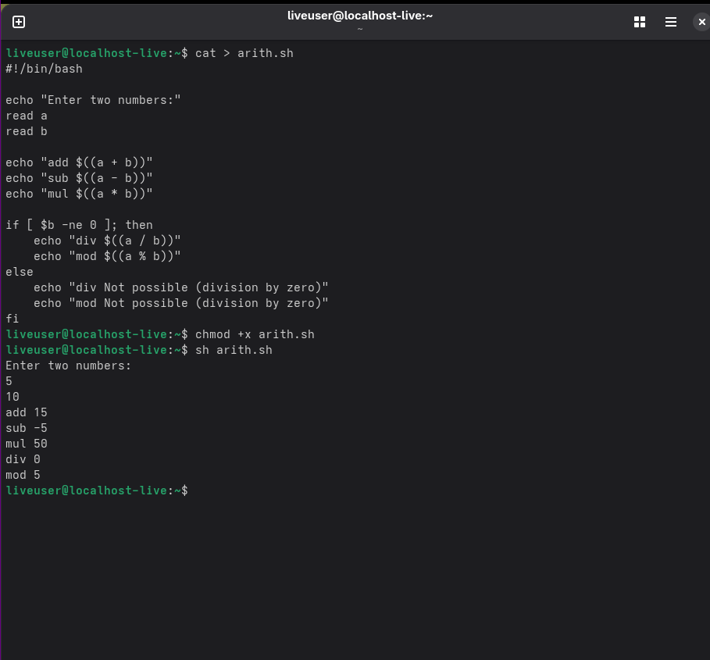

LEAP YEAR

